**Flight Reservation System**

**Abstract**

This project endeavors to create an advanced flight reservation system by utilizing cutting-edge technologies such as Spring Boot, Thymeleaf, JSP, and Google Cloud SQL. The primary objective is to develop a user-friendly platform that enables seamless searching, booking, and management of flight reservations. Leveraging Spring Boot's capabilities for rapid development and simplified configuration, combined with Thymeleaf and JSP for dynamic web page rendering, the system's interface will be both responsive and visually appealing. Additionally, integrating Google Cloud SQL will ensure robust data storage and management, offering scalability and reliability. Ultimately, this system aims to provide users with an optimized flight booking experience, enhancing efficiency and convenience in travel planning while meeting modern technological standards.

**Objectives**

1. User-Friendly Reservation Process:
2. Allow users to search for flights based on various criteria (date, destination, etc.).
3. Provide an intuitive and user-friendly interface for making reservations.
4. Manage Flights and Reservations:
5. Enable administrators to manage flight schedules, add new flights, and view reservation details.
6. Payment Integration (Optional):

Technology Stack

**Backend:**

Spring Boot: For building robust and scalable backend services.

Hibernate: For Object-Relational Mapping (ORM) and data persistence.

Google Cloud: For real-time data synchronization and user authentication.

**Frontend:**

Thymeleef: it is a modern server-side Java template engine for web and standalone environments. Thymeleaf stands out for its natural templating capabilities and seamless integration with Spring Framework.

**Functional and Non-Functional Requirements**

**Functional Requirements:**

1. User Authentication:

* Users should be able to register, log in, and manage their profiles securely.

2. Flight Search and Booking:

* Users can search for available flights based on criteria and book seats.

3. Reservation Management:

* Users should be able to view, modify, or cancel their flight reservations.

4. Real-time Data Synchronization:

* Data, including flight availability and reservations, should be synchronized in real-time between the Spring Boot backend and Firebase Database.

**Non-Functional Requirements:**

1. Performance:

* The performance requirements focus on the system's responsiveness and efficiency under different conditions.

2. Security:

* Security requirements are essential to protect user data, ensure secure communication, and prevent unauthorized access.

3. User Experience:

* User Experience (UX) requirements focus on ensuring a positive and intuitive interaction for users.

**Software and hardware requirements**

**Software Requirements:**

**Java Development Kit (JDK):**

Spring Boot is a Java-based framework, necessitating the installation of JDK on your development machine. Obtain the latest JDK version from the official Oracle website or opt for OpenJDK, an open-source alternative.

**Integrated Development Environment (IDE):**

Employ renowned IDEs such as Eclipse, or Spring Tool Suite for Spring Boot application development.

**Spring Boot Framework:**

Spring Boot facilitates the swift establishment and development of production-ready Spring applications.

**Thymeleaf Templating Engine:**

Thymeleaf serves as a contemporary server-side Java template engine suitable for web and standalone environments.

**Cloud Firebase SDK:**

Firebase offers an array of tools and services tailored for mobile and web application development.

**Hardware Requirements:**

**Device Requirements.**

Recommended specifications entail a multi-core processor, at least 8 GB of RAM, and 256 GB storage space.

**Internet Connection:**

A stable internet connection is indispensable for downloading software dependencies.

**Project Configuration and Structure**

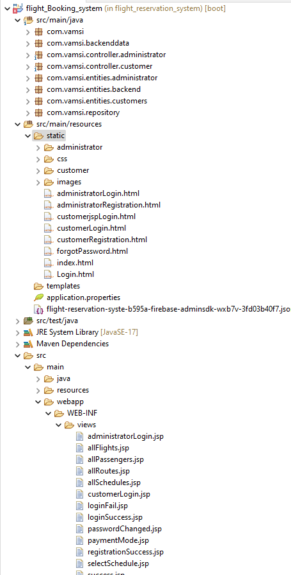

The page above illustrates the structure of a Spring Boot project, including its dependency configurations. In this project, both the Spring Boot and Hibernate frameworks are utilized for mapping classes to a database. The database used primarily is a local MySQL instance for storing table data.

The page showcases the execution of the project using a Spring Boot application, currently running on the localhost with port 8080.

**Home page**

The page presents a homepage featuring tabs for registration and login. Registration is available for both customers and administrators.

The page above exhibits customer registration, displaying various fields for user input.

The page above exhibits administrator registration, displaying various fields for user input.

The login page provides options for different user types, including Customer and Administrator, for accessing the application.

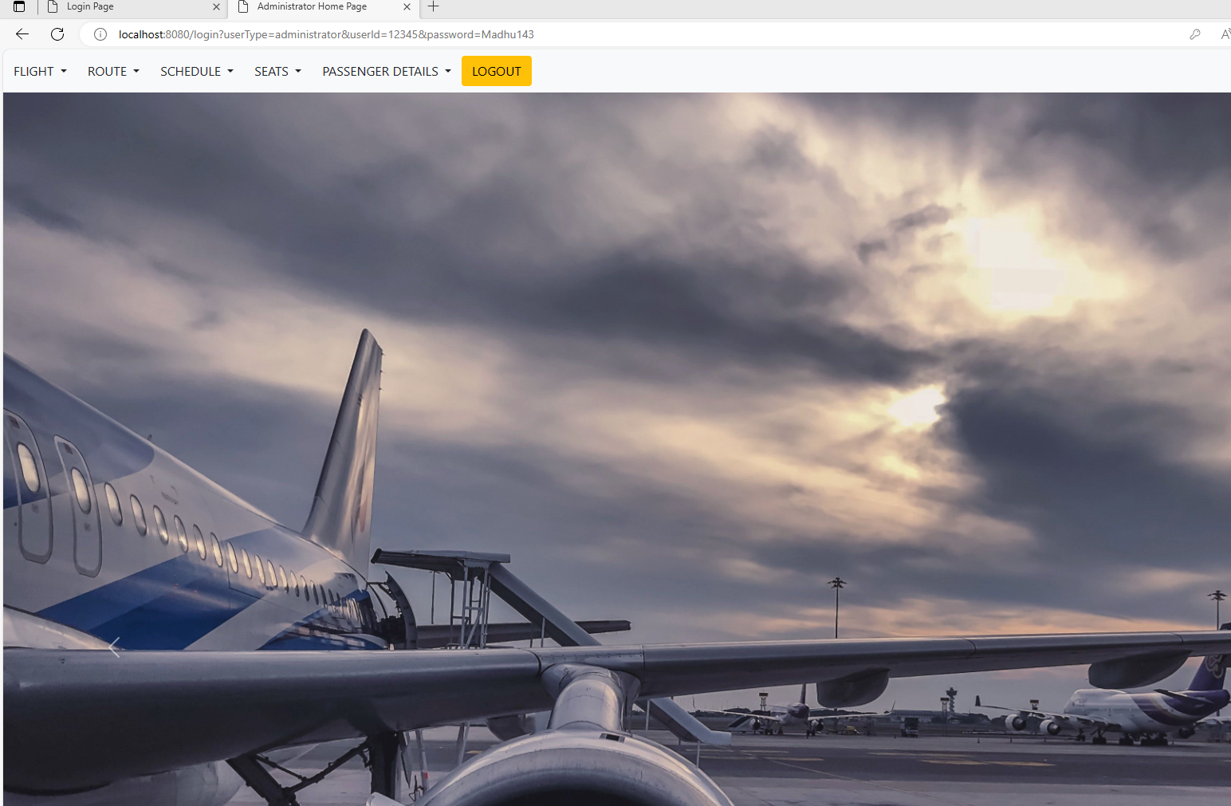

This page demonstrates the capability for administrators to input details such as flights, routes, schedules, and seat assignments, as well as access passenger information.

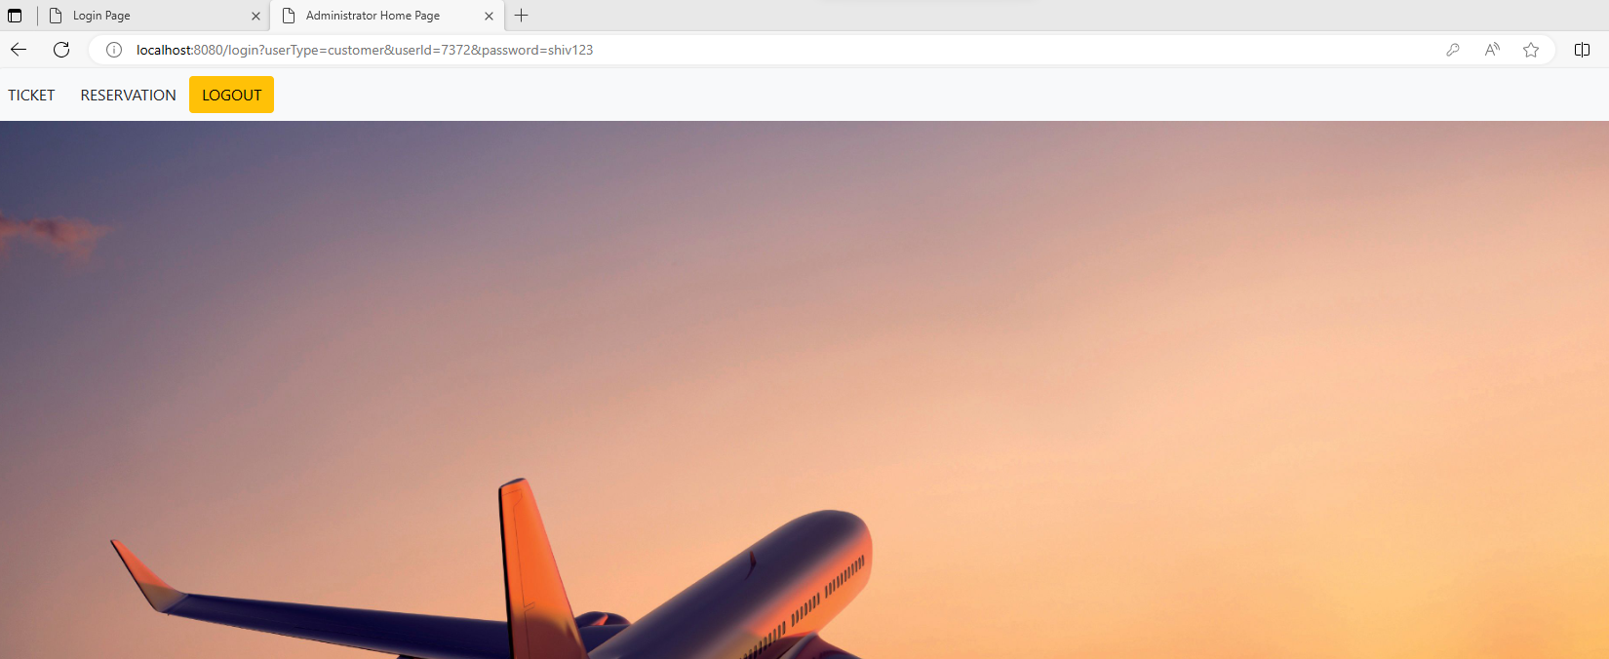

This page serves as the customer homepage, allowing users to book tickets and review reservation details.

Here, customers can enter their details to book a ticket.

Ticket Reservation at customer provides the details of Flight schedule and Fare details to book the ticket.

**Sample cloud sql database screenshots**

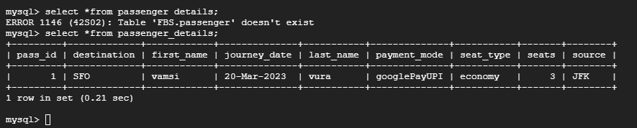

The preceding pages showcase the database operations of the Flight Booking System, illustrating the processes involved in storing and accessing data efficiently.

Conclusion

In conclusion, the flight reservation system provides a comprehensive solution catering to both customers and administrators. Its features encompass registration, login, booking, and flight management, all accessible through a user-friendly interface. With capabilities tailored to different user types and essential functionalities like seat selection and reservation tracking, the system aims to streamline the flight booking experience. Currently, the system operates smoothly with a cloud MySQL database, facilitating enhanced scalability and accessibility.